**Department of Computer Science**

**Question 1/Task 1**: Hospital Management: Describe major services (functionality) provided by a hospitals reception.

**Answer:**

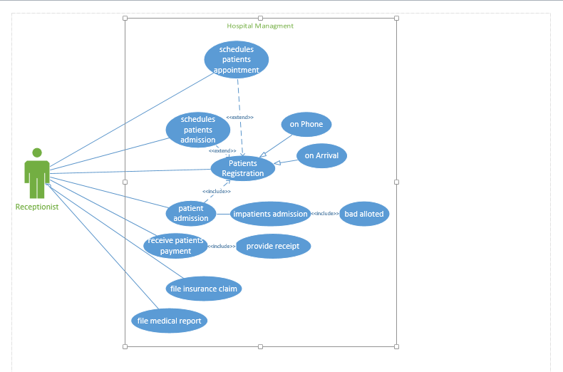

**Question 2/Task 2:**

A user placing an order with a sales company might follow these steps:

1. Browse catalog and select items.

2. Call sales representative.

3. Supply shipping information.

4. Supply payment information.

5. Receive conformation number from salesperson.

**Answer:**

